Judge reveals plan to redo House map
Hinchey district would be split among 4
By Michael Randall Times Herald-Record

Published: 2:00 AM - 03/07/12
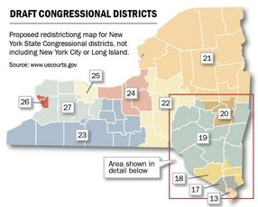
Rep. Maurice Hinchey's old 22nd Congressional District would be divided among four other districts under a federal magistrate's proposed political boundaries issued Tuesday.

Rep. Nan Hayworth's district — to be renumbered the 18th district — would remain largely intact, and she would pick up the northern communities of Orange County now represented by Hinchey, D-Hurley, who is retiring.

Another big chunk of the eastern half of Hinchey's 22nd District, Sullivan and Ulster counties, would form the southern end of the new 19th District. The proposed district would stretch north along both sides of the Hudson River to surround, but not include, Albany and its adjacent counties. Rep. Chris Gibson, R-Kinderhook, would be the incumbent in the new 19th District.

The western half of Hinchey's district — covering the Binghamton area up to Ithaca — would be split between newly proposed 22nd and 23rd districts.
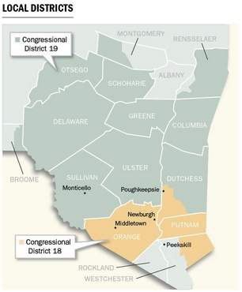

The preliminary draft from federal Magistrate Roanne Mann drew praise from some, while others predict it will encourage state lawmakers to come up with their own plan. They need to come up with a final plan by March 15, or Mann will have the final word.

Hopefuls praise proposed lines

Julian Schreibman of Kingston, a Democrat running for Congress, predicted the final map will look much like the one released Tuesday.

"It's a logical district, a good district," Schreibman said.

Hayworth, R-Mount Kisco, would likely do well in the new district reflected by Mann's proposed map, according to Hayworth spokesman Jay Townsend. But he predicted state lawmakers will take another stab at the map.

"It's totally unpredictable," Townsend said of the process.

Dr. Richard Becker, a potential Hayworth Democratic opponent, liked Mann's map, even though it would mean he'd have to move a short distance in Westchester County to stay in her district.

Likely Hayworth rival sees edge

Another possible Hayworth opponent, Wappingers Falls Mayor Matt Alexander, saw the map favoring his chances.

Alexander's campaign manager, T.J. Helmstetter, said the proposed map "bears out our earlier predictions — this seat is moving north and west. While we are losing portions of Westchester, we are gaining Democratic strongholds including Newburgh and Middletown." That, he added, requires a candidate with experience, fundraising power and name recognition north of Westchester County.

Meanwhile, Gibson said his focus remained on his work, not his district boundary lines.

"The current redistricting process is one that is beyond our control," Gibson said in a statement released by his office. "Regardless of the ultimate outcome, the congressman will continue to work to serve the interests of upstate New Yorkers."

